**CNS MODEL EXAM – 10.11.2020**

**BATCH 2**

**NAME : VAISHALI R**

**REG.NO: 312217104181**

**CSE-C**

**5) HILL CIPHER**

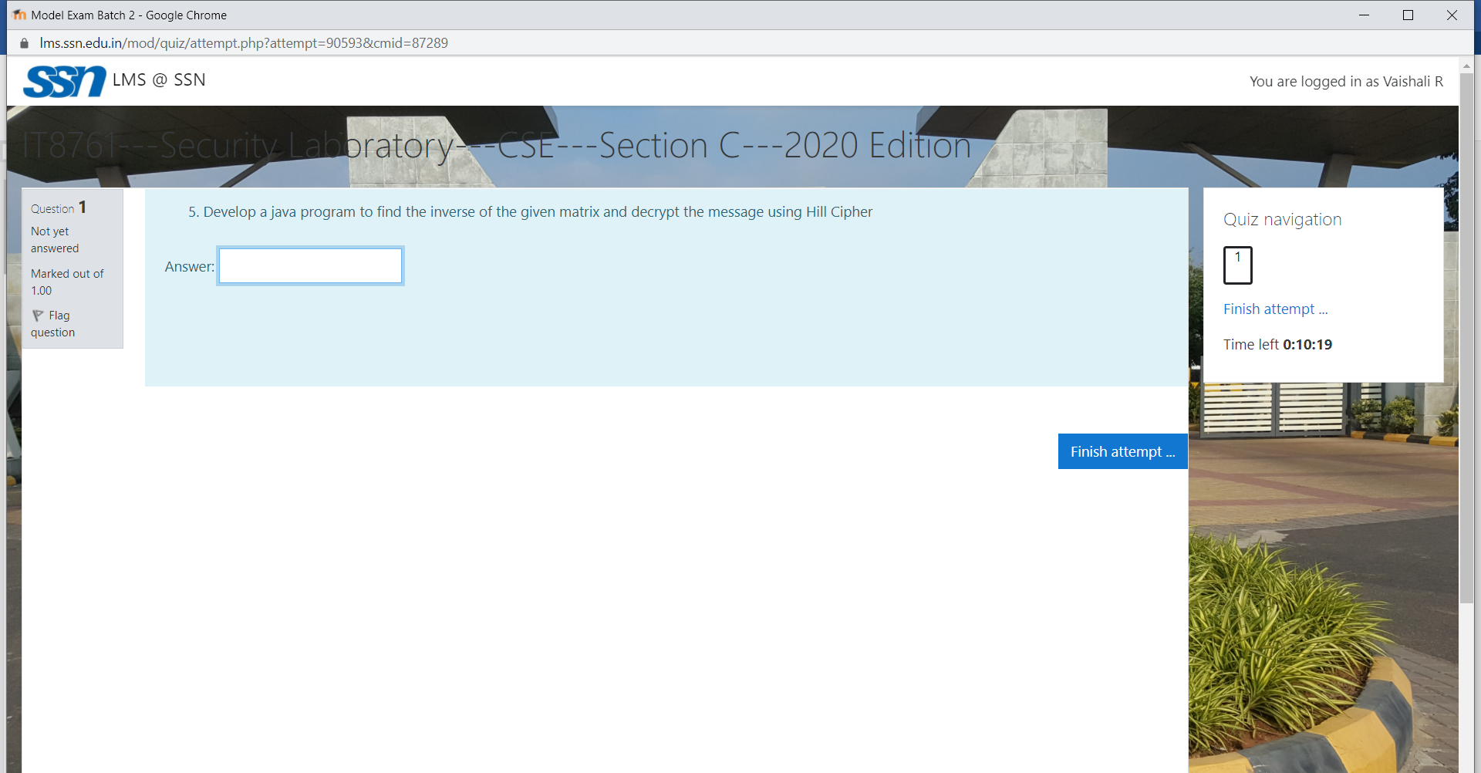

**CODE:**

import java.util.Scanner;

class Main {

String cipherText;

String plainText;

String key;

int cipherMat[][]=new int[3][1];

int plainMat[][]= new int [3][1];

int keyMat[][]=new int[3][3];

int inv_keyMat[][]=new int[3][3];

int adj[][]=new int[3][3];

int d;

int detInv;

void printCipherMat(){

int idx=0;

System.out.println("The plain text matrix is: ");

for(int i=0;i<3;i++){

cipherMat[i][0]=cipherText.charAt(idx++)-65;

System.out.println(cipherMat[i][0]);

}

}

void printPlainMat(){

int idx=0;

System.out.println("The cipher text matrix is: ");

for(int i=0;i<3;i++){

plainMat[i][0]=plainText.charAt(idx++)-65;

System.out.println(plainMat[i][0]);

}

}

void printKeyMat(){

int idx=0;

System.out.println("The key matrix is: ");

for(int i=0;i<3;i++){

for(int j=0;j<3;j++){

keyMat[i][j]=key.charAt(idx++)-65;

System.out.print(keyMat[i][j]+" ");

}

System.out.println();

}

}

public boolean validateKey(String key){

return key.length()==9;

}

void findAdjointMat(){

int sign=1;

int cofactor[][]=new int [3][3];

for(int i=0;i<3;i++){

for(int j=0;j<3;j++){

findCofactorMat(keyMat,3,cofactor,i,j);

if((i+j)%2==0)

sign=1;

else

sign=-1;

adj[j][i]=sign*findDet(cofactor,2);

while(adj[j][i]<0){

adj[j][i]+=26;

}

}

}

System.out.println("\nThe adjoint matrix is ");

for(int i=0;i<3;i++){

for(int j=0;j<3;j++){

System.out.print(adj[i][j]+" ");

}

System.out.println();

}

}

void findInverseKeyMat(){

detInv=findInverse(d,26);

System.out.println("\nThe det value is "+d);

System.out.println("\nThe det inv value is "+detInv);

System.out.println("The inverse key matrix is: ");

for(int i=0;i<3;i++){

for(int j=0;j<3;j++){

inv_keyMat[i][j]=(adj[i][j]*detInv)%26;

System.out.print(inv_keyMat[i][j]+" ");

}

System.out.println();

}

}

void findCofactorMat(int mat[][],int n,int cofactor[][],int r,int c){

int x=0,y=0;

for(int i=0;i<n;i++){

for(int j=0;j<n;j++){

if(i!=r && j!=c){

cofactor[x][y++]=mat[i][j];

if(y==n-1){

x++;

y=0;

}

}

}

}

}

int findDet(int mat[][],int n){

int det=0,sign=1;

int cofactor[][] =new int[3][3];

if(n==1) return mat[0][0];

for (int i=0;i<n;i++){

findCofactorMat(mat,n,cofactor,0,i);

det+=(sign*mat[0][i]*findDet(cofactor,n-1));

sign=-1*sign;

}

while(det<0){

det+=26;

}

det=det%26;

return det;

}

int findInverse(int x,int m){

x=x%m;

for(int i=0;i<m;i++){

if((x*i)%m==1)

return i;

}

return 1;

}

boolean isInvertible(){

d=findDet(keyMat,3);

if(d==0 || d%13==0 || d%2==0)

return false;

return true;

}

String decrypt(){

System.out.println("\nThe plain text matrix is: ");

for(int i=0;i<3;i++){

for(int j=0;j<1;j++){

plainMat[i][j]=0;

for(int k=0;k<3;k++){

plainMat[i][j]+=inv_keyMat[i][k]*cipherMat[k][j];

}

plainMat[i][j]=plainMat[i][j]%26;

System.out.print(plainMat[i][j]+" ");

}

System.out.println();

}

plainText="";

for(int i=0;i<3;i++){

plainText+=(char)(plainMat[i][0] + 65);

}

//System.out.println("The plaintext is "+plainText);

return plainText;

}

String encrypt(){

System.out.println("\nThe cipher text matrix is: ");

for(int i=0;i<3;i++){

for(int j=0;j<1;j++){

cipherMat[i][j]=0;

for(int k=0;k<3;k++){

cipherMat[i][j]+=keyMat[i][k]*plainMat[k][j];

}

cipherMat[i][j]=cipherMat[i][j]%26;

System.out.print(cipherMat[i][j]+" ");

}

System.out.println();

}

cipherText="";

for(int i=0;i<3;i++){

cipherText+=(char)(cipherMat[i][0] + 65);

}

//System.out.println("The cipher text is "+cipherText);

return cipherText;

}

public static void main(String[] args) {

Main hc=new Main();

Scanner sc= new Scanner(System.in);

System.out.println("HILL CIPHER ENCRYPTION");

System.out.print("\nEnter the plain text: ");

String pt =sc.next();

System.out.print("\nEnter the key: ");

hc.key=sc.next();

while(!hc.validateKey(hc.key)){

System.out.println("Invalid key");

System.out.println("Enter the key: ");

hc.key=sc.next();

}

String ct="";

hc.printKeyMat();

for(int i=0;i<pt.length();i=i+3){

hc.plainText=pt.substring(i,i+3);

hc.printPlainMat();

ct+=hc.encrypt();

}

System.out.println("The cipher text is "+ct);

System.out.println("\nHILL CIPHER DECRYPTION");

System.out.print("\nEnter the cipher text: ");

ct=sc.next();

System.out.print("\nEnter the key: ");

hc.key=sc.next();

while(!hc.validateKey(hc.key)){

System.out.println("Invalid key");

System.out.println("Enter the key: ");

hc.key=sc.next();

}

pt="";

hc.printKeyMat();

if(hc.isInvertible()){

System.out.println("\nKey Matrix is invertible");

hc.findAdjointMat();

hc.findInverseKeyMat();

for(int i=0;i<ct.length();i=i+3){

hc.cipherText=ct.substring(i,i+3);

hc.printCipherMat();

pt+=hc.decrypt();

}

System.out.println("The plain text is "+pt);

}

else{

System.out.println("Key Matrix is not invertible");

}

}

}

**OUTPUT:**

**EXAMPLE 1:**

**PLAINTEXT: PAY**

**KEY: BACKUPABC**

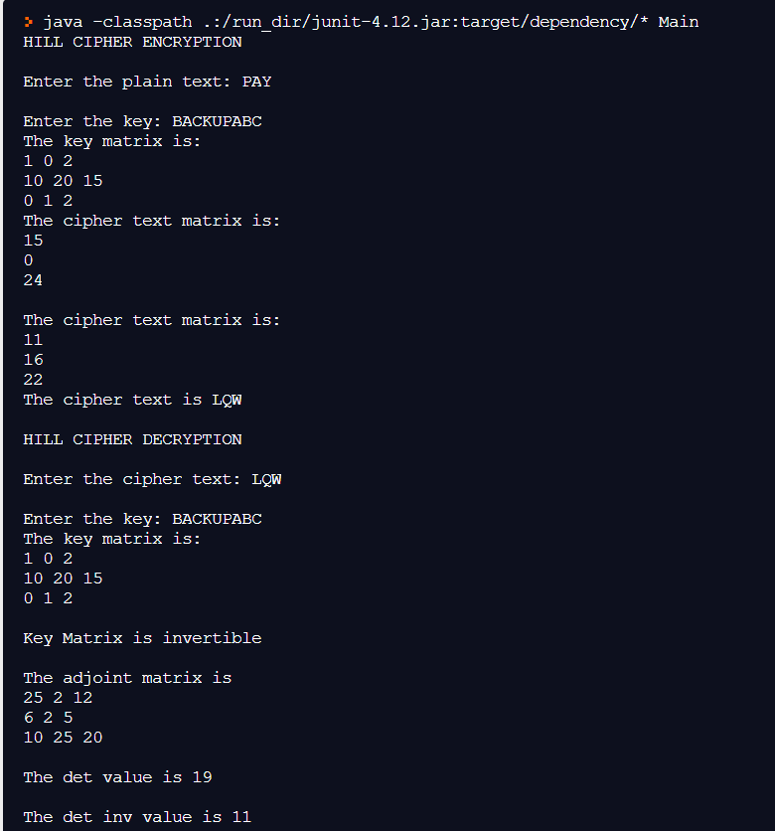

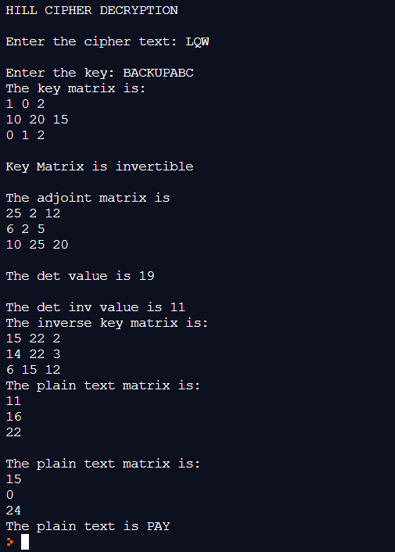

**EXAMPLE 2:**

**PLAINTEXT: PAYMOREMONEY**

**KEY:ALPHABETA**

